Ideation Phase
Define the Problem Statements

Date | 22 January 2026
Team ID | LTVIP2026TMIDS62799
Project Name | Smart Sorting: Transfer Learning for Identifying Rotten Fruits and Vegetables
Maximum Marks | 2 Marks

Customer Problem Statement Template:
In food processing plants, supermarkets, and modern households, identifying rotten fruits and vegetables remains a major challenge that affects quality, operational efficiency, cost management, and customer satisfaction. Current sorting and monitoring processes depend largely on manual inspection, which is time-consuming, labor-intensive, inconsistent, and prone to human error, especially when handling large volumes of perishable goods daily. Workers may miss early signs of spoilage due to fatigue or workload pressure, leading to contaminated batches, increased food waste, financial losses, and reduced consumer trust. Customers such as food processing industries, retail stores, and households need a fast, reliable, and intelligent system that can accurately detect rotten produce in real time while minimizing manual effort and ensuring consistent quality control. The core problem is the absence of an automated, scalable, and highly accurate solution for detecting and separating spoiled fruits and vegetables, and this gap can be effectively addressed through an AI-powered smart sorting system using transfer learning to enable real-time image-based classification, reduce waste, improve efficiency, and enhance overall freshness standards.
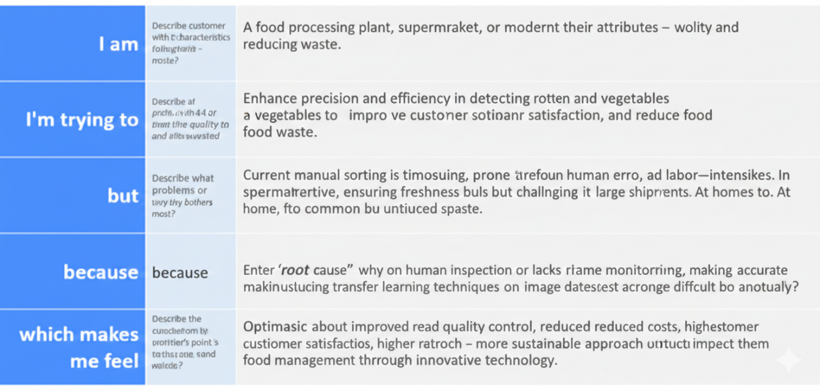
Reference: https://miro.com/templates/customer-problem-statement/
Example:
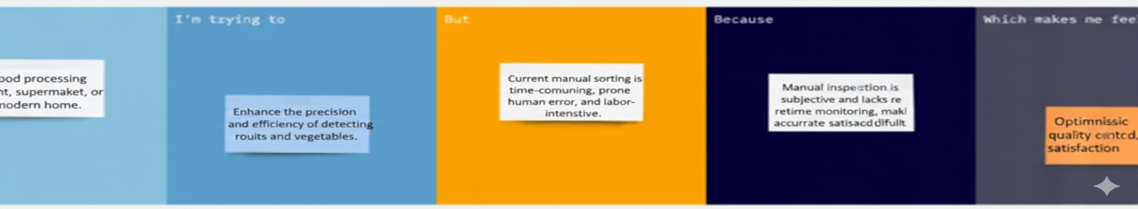
Problem Statement (PS) | I am (Customer) | I’m trying to | But | Because | Which makes me feel
PS-1
PS-2

